

**[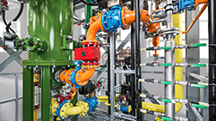](http://www.sglgroup.com/cms/international/products/product-groups/ps/system-solutions/index.html)** [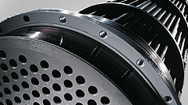](http://www.sglgroup.com/cms/international/products/product-groups/pt/graphite-heat-exchangers/index.html) [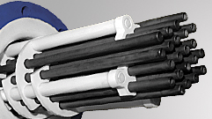](http://www.sglgroup.com/cms/international/products/product-groups/pt/sicabon-heat-exchangers/index.html)

[**System Solutions**](http://www.sglgroup.com/cms/international/products/product-groups/ps/system-solutions/index.html) [**Graphite Heat Exchangers**](http://www.sglgroup.com/cms/international/products/product-groups/pt/graphite-heat-exchangers/index.html) [**Silicon Carbide Heat Exchangers**](http://www.sglgroup.com/cms/international/products/product-groups/pt/sicabon-heat-exchangers/index.html)

[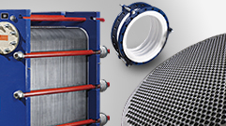](http://www.sglgroup.com/cms/international/products/product-groups/pt/index.html) [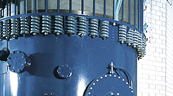](http://www.sglgroup.com/cms/international/products/product-groups/pt/quenchers/index.html) [](http://www.sglgroup.com/cms/international/products/product-groups/pt/pumps/index.html)

[**Plate Heat Exchanger**](http://www.sglgroup.com/cms/international/products/product-groups/su/index.html)  [**Quenchers**](http://www.sglgroup.com/cms/international/products/product-groups/pt/quenchers/index.html) [**Pumps**](http://www.sglgroup.com/cms/international/products/product-groups/pt/pumps/index.html)

**[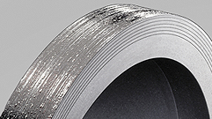](http://www.sglgroup.com/cms/international/products/product-groups/pt/rupture-discs/index.html)** [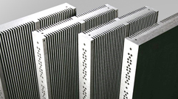](http://www.sglgroup.com/cms/international/products/product-groups/pt/special-heat-exchangers/index.html) [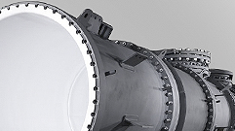](http://www.sglgroup.com/cms/international/products/product-groups/pt/PTFE/process-equipment-and-vessels/index.html)

[**Rupture Disks**](http://www.sglgroup.com/cms/international/products/product-groups/pt/rupture-discs/index.html) [**Special Heat Exchangers**](http://www.sglgroup.com/cms/international/products/product-groups/pt/special-heat-exchangers/index.html) [**Columns, Reactors and Vessels**](http://www.sglgroup.com/cms/international/products/product-groups/pt/PTFE/process-equipment-and-vessels/index.html)

[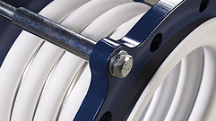](http://www.sglgroup.com/cms/international/products/product-groups/pt/PTFE/expansion-joints-bellows/index.html) [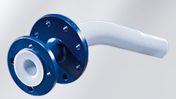](http://www.sglgroup.com/cms/international/products/product-groups/pt/PTFE/dip-and-inlet-pipes/index.html) [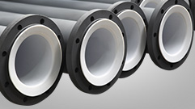](http://www.sglgroup.com/cms/international/products/product-groups/pt/PTFE/piping-systems/index.html)

[**Expansion Joints/ Bellows**](http://www.sglgroup.com/cms/international/products/product-groups/pt/PTFE/expansion-joints-bellows/index.html) [**[Dip Pipes and Inlet Pipes](http://www.sglgroup.com/cms/international/products/product-groups/pt/index.html)**](http://www.sglgroup.com/cms/international/products/product-groups/pt/PTFE/dip-and-inlet-pipes/index.html)[**[Piping](http://www.sglgroup.com/cms/international/products/product-groups/pt/index.html)**](http://www.sglgroup.com/cms/international/products/product-groups/pt/PTFE/piping-systems/index.html)

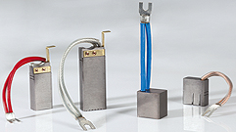 [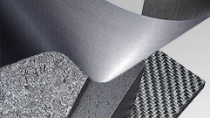](http://www.sglgroup.com/cms/international/products/product-groups/su/index.html) [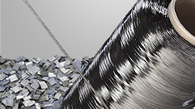](http://www.sglgroup.com/cms/international/products/product-groups/cf/index.html)

[**Carbon Brushes**](http://www.sglgroup.com/cms/international/products/product-groups/cfrc_felt/specialty-graphites-for-energy-storage/index.html) [**Carbon Fiber-Reinforced Felt**](http://www.sglgroup.com/cms/international/products/product-groups/cfrc_felt/index.html) [**Carbon Fibers**](http://www.sglgroup.com/cms/international/products/product-groups/cf/index.html)

[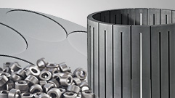](http://www.sglgroup.com/cms/international/products/product-groups/fgg/index.html) [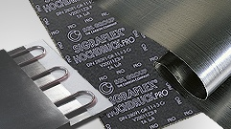](http://www.sglgroup.com/cms/international/products/product-groups/eg/index.html) [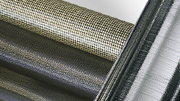](http://www.sglgroup.com/cms/international/products/product-groups/cm/index.html)

[**Fine Grain Graphite**](http://www.sglgroup.com/cms/international/products/product-groups/fgg/index.html) [**Expanded Graphite**](http://www.sglgroup.com/cms/international/products/product-groups/eg/index.html) [**Composite Materials**](http://www.sglgroup.com/cms/international/products/product-groups/cm/index.html)

[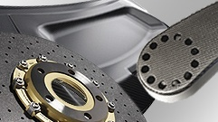](http://www.sglgroup.com/cms/international/products/product-groups/cc/index.html) [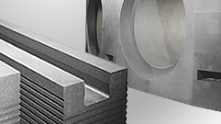](http://www.sglgroup.com/cms/international/products/product-groups/cfl/index.html) 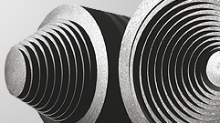

[**Composite Components**](http://www.sglgroup.com/cms/international/products/product-groups/cc/index.html) [**Cathodes, Furnace Linings Carbon Electrodes**](http://www.sglgroup.com/cms/international/products/product-groups/cfl/index.html)

[](http://www.sglgroup.com/cms/international/products/product-groups/fgg/specialty-graphites-for-glass-and-refractory/index.html) 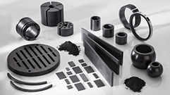 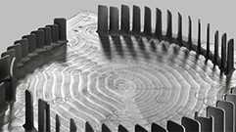

[**Glass and Refractory Industries**](http://www.sglgroup.com/cms/international/products/product-groups/fgg/specialty-graphites-for-glass-and-refractory/index.html) [**Carbon Seals & Bushes**](http://www.sglgroup.com/cms/international/products/product-groups/pt/after-sales-services/index.html) [**Electrical Discharge Machining**](http://www.sglgroup.com/cms/international/products/product-groups/pt/PTFE/supplementary-components/index.html)